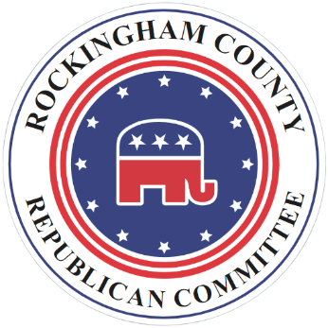 Rockingham County Republican Committee
P.O. Box 787
Harrisonburg, VA 22803

September 22, 2023
For More Information Contact:
Daryl Borgquist, 703-297-0917

Virginia AG Jason Miyares Endorses Rockingham County Local Candidates

HARRISONBURG, VIRGINIA - The Rockingham County Republican Committee is pleased to announce the endorsement of our endorsed school board candidates Ashley Burgoyne (District 2), Sara Horst (District 4), and Hollie Cave (District 5).

Attorney General Jason Miyares, who met with the candidates earlier in the week said: “Our local elections matter. In Rockingham County, I’m happy to support our Republican-endorsed school board candidates. They understand the simple principle that parents matter.”

Miyares also added his endorsement to the Rockingham County Republican nominees for supervisor: Leila Longcor in District 4 and Joel Hensley in District 5. Miyares said, “I’m proud to support the Republican endorsed Board of Supervisors candidates in Rockingham County. They will support our police and ensure that we keep taxes low.”

###

