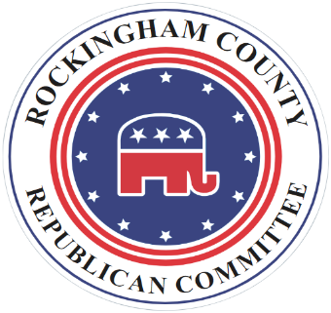

Rockingham County Virginia Republican Committee

Resolution Encouraging the Republican National Committee
to be Loyal to Grass Roots Republican Voters

Whereas, the Republican National Committee (RNC) leads the Republican Party of the United States; and

Whereas, Republican leadership positions at every level of the Republican Party, especially Republican elected officials, are expected to engage in ethical practices as members in a principled party reflected in its platform and the Virginia Republican Creed; and

Whereas, the RNC raised funds in support of Republican House and Senate candidates largely through sales of Donald J. Trump merchandise from Republican grassroots supporters; and

Whereas, Donald J. Trump, received more than 74,222,958 votes or 46.8 percent of the votes – more than any other president received except for Joe Biden who won in 2020; and

Whereas, the nation is still in need of renewal based on the eleven Republican principles of the 2020 campaign: growing America’s economy not Washington’s; real healthcare reform; respect for veterans; protecting Americans at home and American interests abroad; giving equal opportunities for education; valuing traditions of families, freedom, religious liberty, and hard work; energy independence, securing our borders and having effective immigration policies; and

Whereas, after 2020 Republican voters remain deeply concerned about election integrity in the 50 states and the District of Columbia; and

Be It Therefore Resolved by the Rockingham County Republican Committee to Encourage the Republican National Committee to be loyal to grass roots Republican voters who provide its financial support; and be it further

Resolved, on behalf of grassroots voters, Republican elected officials who have not stood with President Trump and who voted for his impeachment, should be ineligible for receiving any future funds from the RNC or any of its subsidiary Republican committees, organizations, or auxiliary organizations in the future; and

Resolved, that 75 million Republican voters did not lose their First Amendment Rights to speak, assemble, or petition their government because several hundred people took advantage of slack security at the U.S. Capitol on January 6, 2021; and

Resolved, that Republican party and elected officials should exemplify high ethical standards and remain true to the Republican principles of American renewal desired by Republican grassroots voters and the 2016 Republican Party Platform that was reissued in 2020; and

Resolved, on behalf of grassroots Republican voters, the RNC should ensure effective Republican state committees in all 50 states and the District of Columbia, assisting with database resources and ensuring Republican candidates are being run for every office in the nation; and

Resolved, on behalf of grassroots Republican voters, the RNC and its state party organizations should aggressively ensure election integrity, having Republican election officials for every jurisdiction and Republican election officers for every precinct in the nation, and proactively challenging unfair or unconstitutional election laws and practices across the nation in a timely way; and

Approved by the Rockingham County Republican Committee on March 17, 2021 to be published to the local community and Virginia State officials.

____________________
Daryl Borgquist, Chairman

